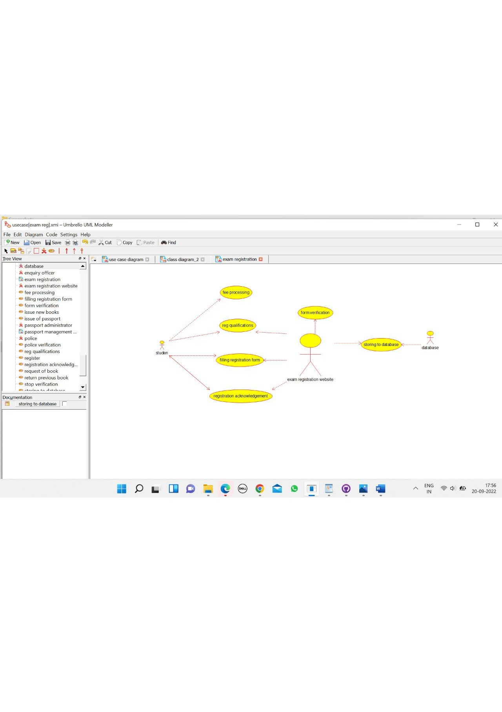

student

/**

* Class students

*/

public class students {

//

// Fields

//

private void name;

private void address;

private void DOB;

private void subjects;

private void college;

//

// Constructors

//

public students () { };

//

// Methods

//

//

// Accessor methods

//

/**

* Set the value of name

* @param newVar the new value of name

*/

private void setName (void newVar) {

name = newVar;

}

/**

* Get the value of name

* @return the value of name

*/

private void getName () {

return name;

}

/**

* Set the value of address

* @param newVar the new value of address

*/

private void setAddress (void newVar) {

address = newVar;

}

/**

* Get the value of address

* @return the value of address

*/

private void getAddress () {

return address;

}

/**

* Set the value of DOB

* @param newVar the new value of DOB

*/

private void setDOB (void newVar) {

DOB = newVar;

}

/**

* Get the value of DOB

* @return the value of DOB

*/

private void getDOB () {

return DOB;

}

/**

* Set the value of subjects

* @param newVar the new value of subjects

*/

private void setSubjects (void newVar) {

subjects = newVar;

}

/**

* Get the value of subjects

* @return the value of subjects

*/

private void getSubjects () {

return subjects;

}

/**

* Set the value of college

* @param newVar the new value of college

*/

private void setCollege (void newVar) {

college = newVar;

}

/**

* Get the value of college

* @return the value of college

*/

private void getCollege () {

return college;

}

//

// Other methods

//

/**

*/

public void form_filling()

{

}

/**

*/

public void registration()

{

}

}

Reg website

/**

* Class reg_website

*/

public class reg_website {

//

// Fields

//

private void qualification;

private void login_details;

private void fee_details;

private void exam_dates;

//

// Constructors

//

public reg_website () { };

//

// Methods

//

//

// Accessor methods

//

/**

* Set the value of qualification

* @param newVar the new value of qualification

*/

private void setQualification (void newVar) {

qualification = newVar;

}

/**

* Get the value of qualification

* @return the value of qualification

*/

private void getQualification () {

return qualification;

}

/**

* Set the value of login_details

* @param newVar the new value of login_details

*/

private void setLogin_details (void newVar) {

login_details = newVar;

}

/**

* Get the value of login_details

* @return the value of login_details

*/

private void getLogin_details () {

return login_details;

}

/**

* Set the value of fee_details

* @param newVar the new value of fee_details

*/

private void setFee_details (void newVar) {

fee_details = newVar;

}

/**

* Get the value of fee_details

* @return the value of fee_details

*/

private void getFee_details () {

return fee_details;

}

/**

* Set the value of exam_dates

* @param newVar the new value of exam_dates

*/

private void setExam_dates (void newVar) {

exam_dates = newVar;

}

/**

* Get the value of exam_dates

* @return the value of exam_dates

*/

private void getExam_dates () {

return exam_dates;

}

//

// Other methods

//

/**

*/

public void verification()

{

}

/**

*/

public void processing()

{

}

/**

*/

public void registration()

{

}

}

University database

/**

* Class university_databases

*/

public class university_databases {

//

// Fields

//

private void exam_details;

private void reg_details;

//

// Constructors

//

public university_databases () { };

//

// Methods

//

//

// Accessor methods

//

/**

* Set the value of exam_details

* @param newVar the new value of exam_details

*/

private void setExam_details (void newVar) {

exam_details = newVar;

}

/**

* Get the value of exam_details

* @return the value of exam_details

*/

private void getExam_details () {

return exam_details;

}

/**

* Set the value of reg_details

* @param newVar the new value of reg_details

*/

private void setReg_details (void newVar) {

reg_details = newVar;

}

/**

* Get the value of reg_details

* @return the value of reg_details

*/

private void getReg_details () {

return reg_details;

}

//

// Other methods

//

/**

*/

public void storing_registration()

{

}

}

